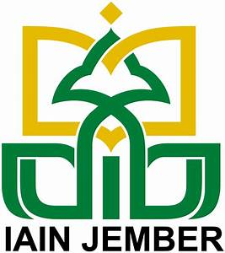 | MEMORANDUM OF UNDERSTANDING  BETWEEN

INSTITUT AGAMA ISLAM NEGERI JEMBER, INDONESIA

AND

INTERNATIONAL ISLAMIC UNIVERSITY MALAYSIA, MALAYSIA

------------------------------------------------------------------------------------------

In the name of Allah the Beneficent the Merciful

Hereby, Institut Agama Islam Negeri (IAIN) or State Institute of Islamic Studies of Jember and Interational Islamic University Malaysia, Malaysia, recognize this Memorandum of Understanding (MoU) would be of mutual benefit and would serve as an indication of continued interest to develop the following forms of cooperation:

Joint seminar, research activities, and academic programs;

Exchange of faculty members for the development of both faculties;

Exchange of Postgraduate students for study and research;

Exchange of community services; including exchange of social-cultural activities; and
Both parties understand that all financial arrangements will have to be negotiated and will depend on the availability of funds.
Details for the implementation of specific projects will be mutually developed.
In the event where both parties formalize the abovementioned academic and research collaboration, the parties have agreed the MoU of which it has a binding effect on both parties.
This MoU shall be effective for a period of three (3) years from the date of final signature. It may be modified or extended by mutual written agreement by the parties. This MoU may be terminated by either party upon six (6) months advance written notice.

Signed in Malaysia on September 19, 2019.

ForInstitut Agama Islam Negeri Jember, Indonesia | Interational Islamic University Malaysia, Malaysia
Prof. Dr. Babun Suharto, SE., MM.  Rector | Professor Emeritus Tan Sri Dato Dzulkifli Abdul Razak  Rector
Witnesses:
Prof. Dr. Abd. Halim Soebahar, MA.  Director, Postgraduate School,  IAIN Jember | Interational Islamic University Malaysia, Malaysia

