Please Find Below The Invoice Of :
Company | PASCASARJANA IAIN JEMBER - JATIM | Check In | 16 FEBRUARI 2019
Contact |  | Check Out | 18 FEBRUARI 2019

No. | Description | Amount
1. | PAKET FULLBOARD MEETING  Rp.540.000 X 30 PAX X 2 HARI  TGL 16 FEB 2019  - CHECK IN 15 ROOM  - COFFEE BREAK  - LUNCH  - COFFEE BREAK  - DINNER  TGL 17 FEB 2019  - BREAKFAST  - COFFEE BREAK  - LUNCH  - COFFEE BREAK  TGL 18 FEB 2019  - BREAKFAST  - CHECK OUT | Rp.32.400.000
 | Sub Total | Rp.32.400.000

Jember, 19 Februari 2019
Regard,
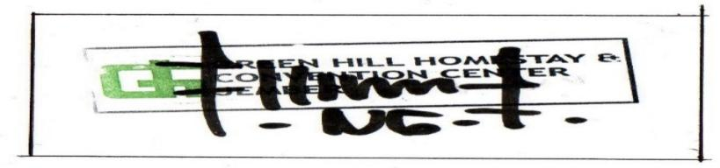

Nanang Dwi Kuncoro
Marketing Manager

